INSTRUCTABLE FILE
“MAKE YOUR OWN LOBSTER HOUSE”

Everywhere across the world, people are aware that protecting the oceans is one of our most urgent issues. Whatever type of marine animal or habitat you want to help - coral, whales, dolphins or marine life in general - you’re motivated to take action, but few of us actually know what to do to help.
Obviously reducing pollution is important, but here is one of the simple ways to proactively help rebuild healthy oceans. Build your own lobster house, nicknamed in Spanish “Casita Mexicana”.
Lobsters in the tropics are spiny lobsters (they have no claws) and like many marine creatures, they need to find a ‘home’ to live, reproduce, and hide from predators. Unlike the clawed lobsters (American and European), the spiny lobsters are sociable and not cannibalistic, so many lobsters can live in one house. Teach A Man To Fish (TAMTF - www.tamtf.net) , a US non-profit organization would like to share an easy and cheap technique to protect the lobsters by making a simple shelter.
Here is the procedure to make a lobster house:
- Find a suitable location. Spiny lobsters live along both the Atlantic and Pacific ocean coastlines of the southern US and tropical countries. Because they are highly desirable food for us humans, they are often overfished!!
- With a few planks to make a mold, 130 lbs of concrete and a few steel rebars, anyone can build a lobster house.
- Once dry and strong, place it in any location on a sandy ocean floor close to the shoreline at a depth of 18 to 40 feet. Simply place it in an appropriate location and nature will take care of the rest.
- Lobsters will find it and call it home. Other marine creatures and fish will also colonize it and within a few months you will no longer see the concrete.

Here is a drawing of a finished lobster house. Note: Instructions for building a Lobster House show it upside down, so mold can hold the concrete.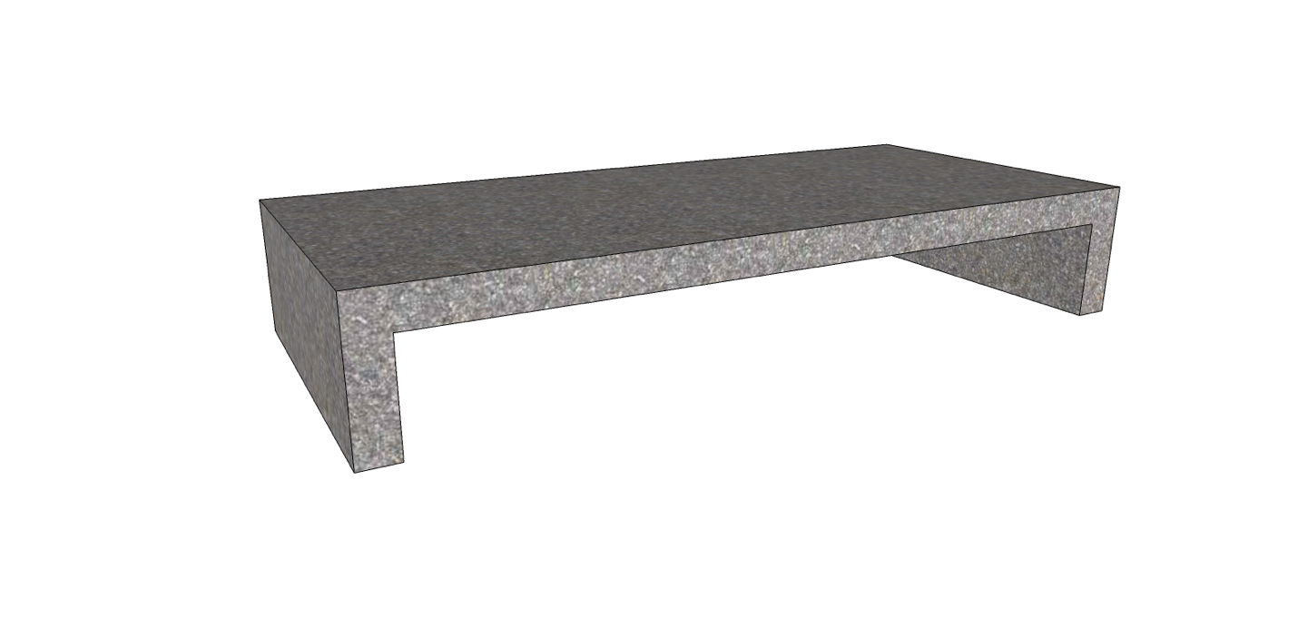
Here is a picture of a finished Lobster House, “Casita Mexicana”.
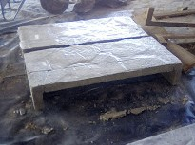

Here is the drawing of the mold, made with wooden planks, 1” thick:
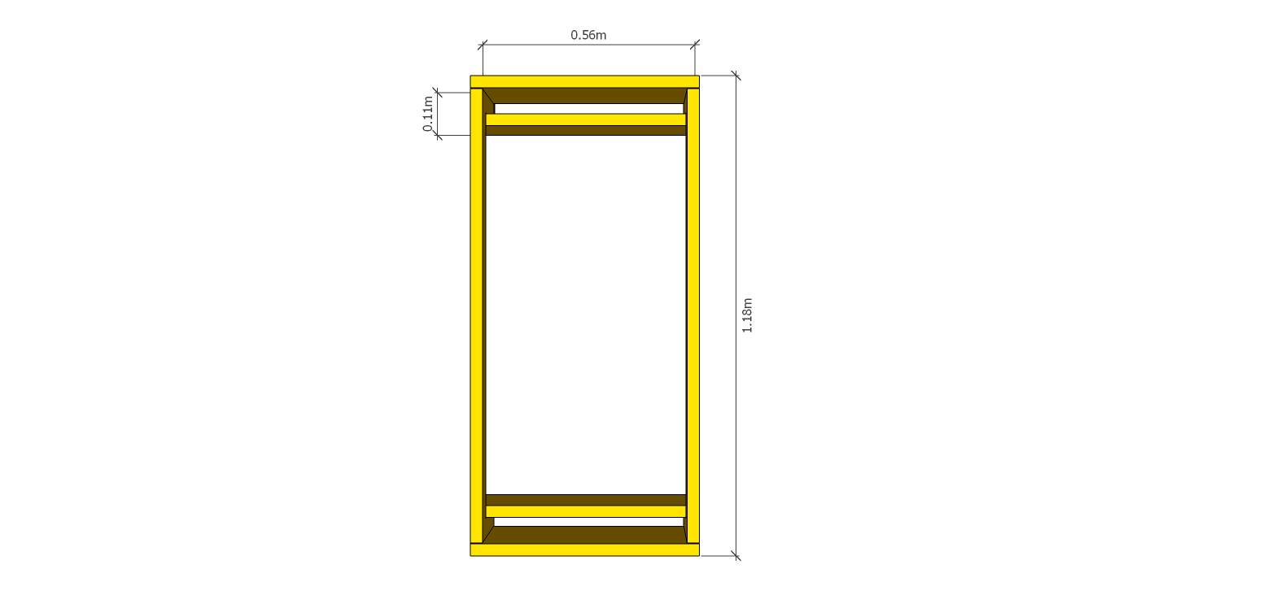

Here is how to build the mold out of wooden planks.
You need 2 units each of the 3 planks (PLANK 1, 2 and 3 shown below):
STEP 1: Cut PLANK 1 board 0.56m x 0.19m
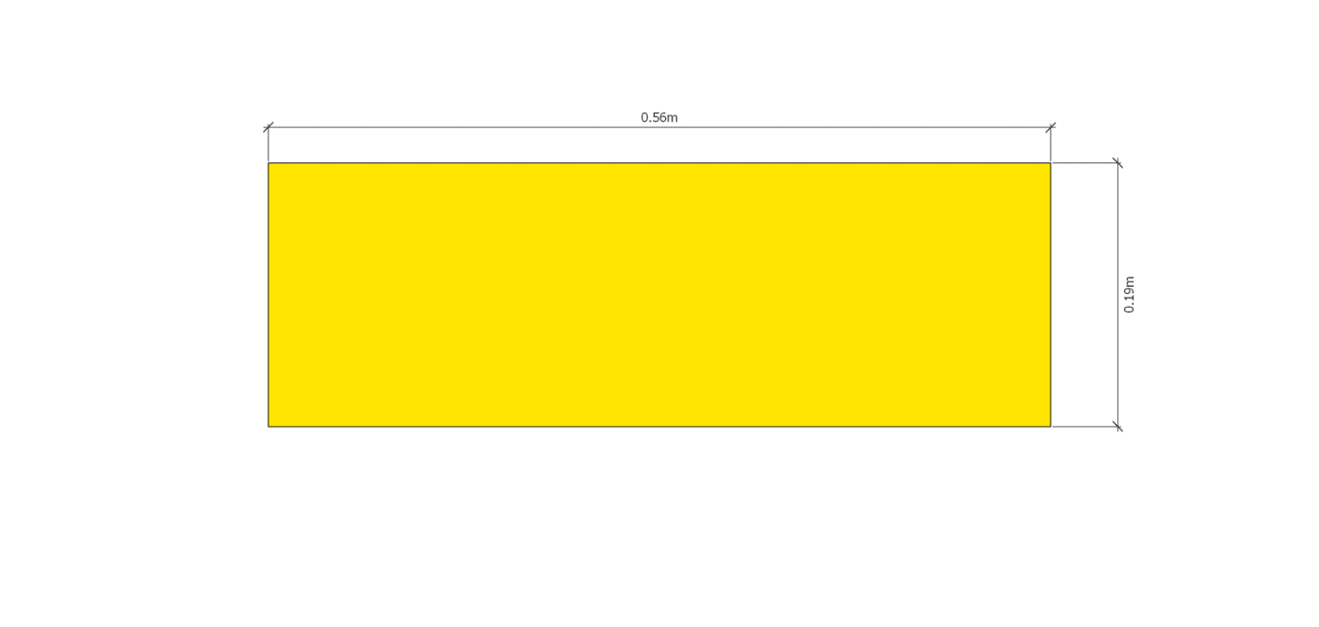

STEP 2: Cut PLANK 2 Board 0.56m x0.14m
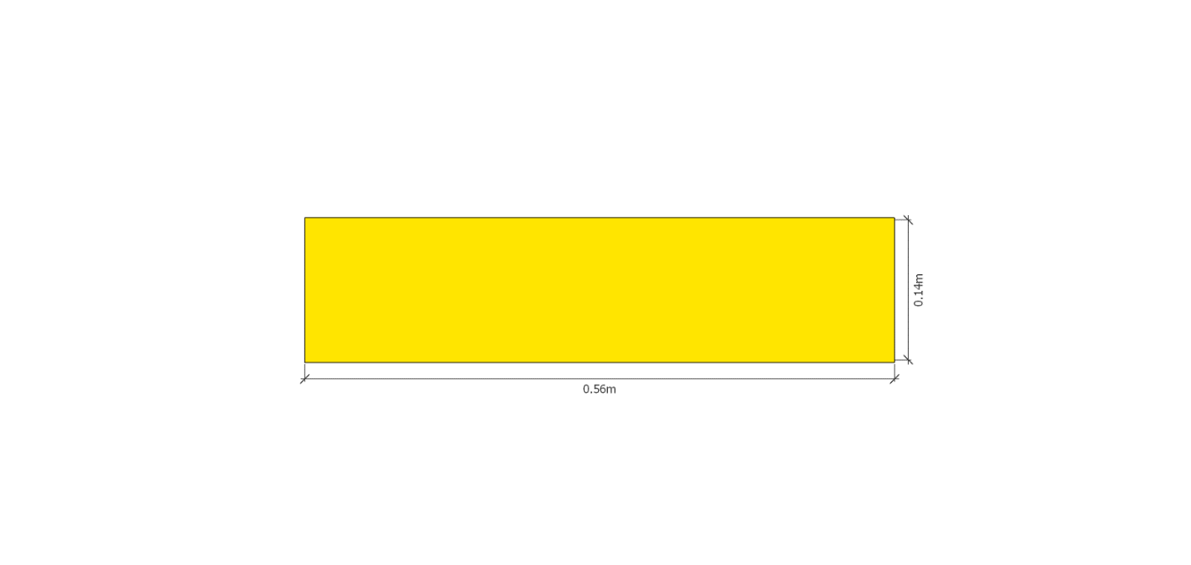
STEP 3: Cut PLANK 3 Board 1.12m x 0.05m with projections at each end 0.14m long x 0.05m wide
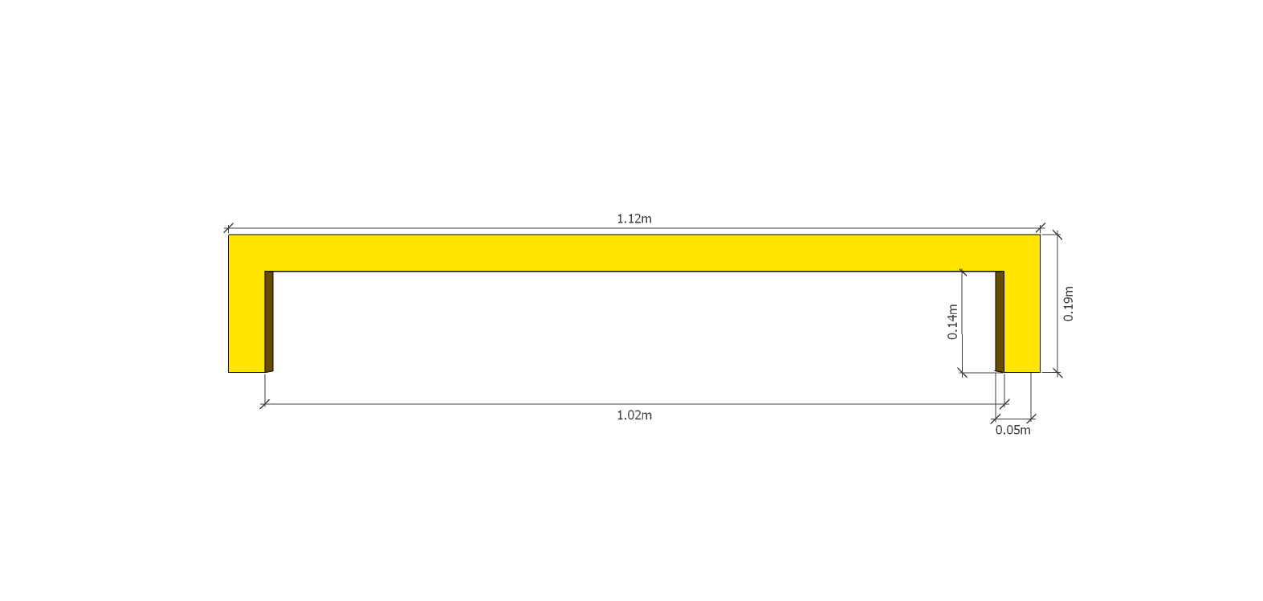

STEP 4: Drill 4 holes through all 3 boards in each end of mold as shown in diagram.
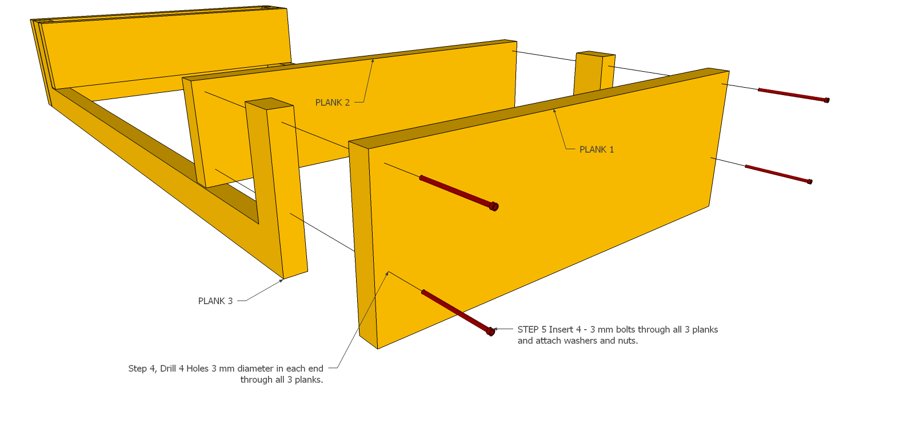

STEP 5: As shown above, insert 4 – 3 mm bolts ( at least 13 mm long) through holes and attach washers and nuts. Completed step 5 shown below.
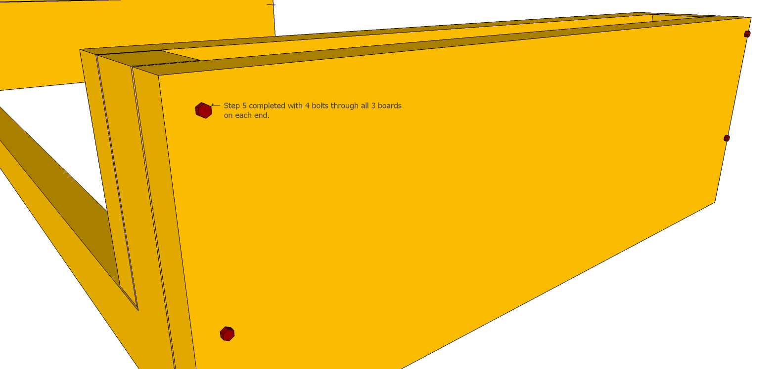

Here are two 3D views of an assembled mold:
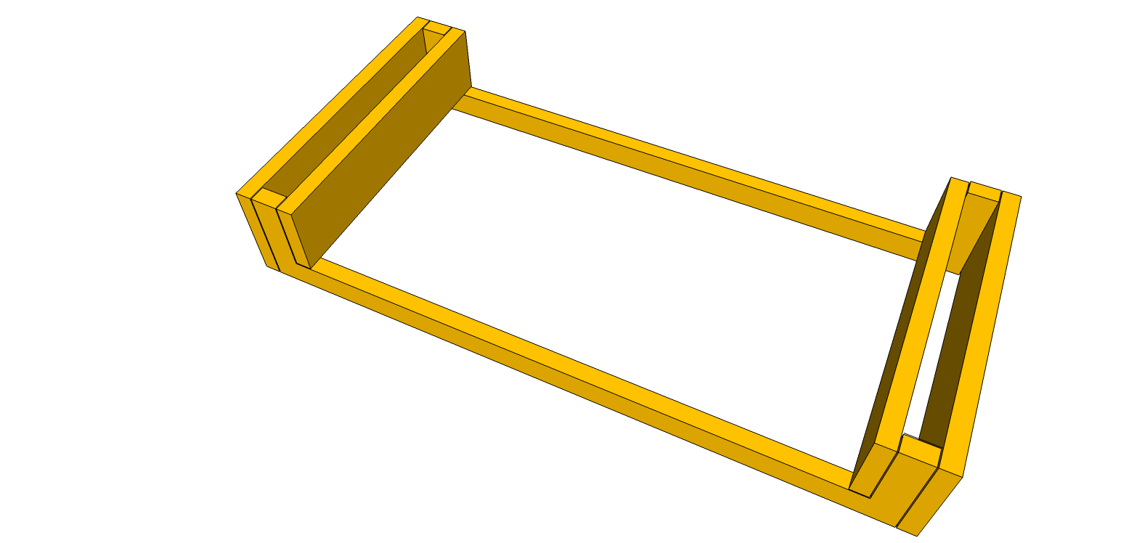
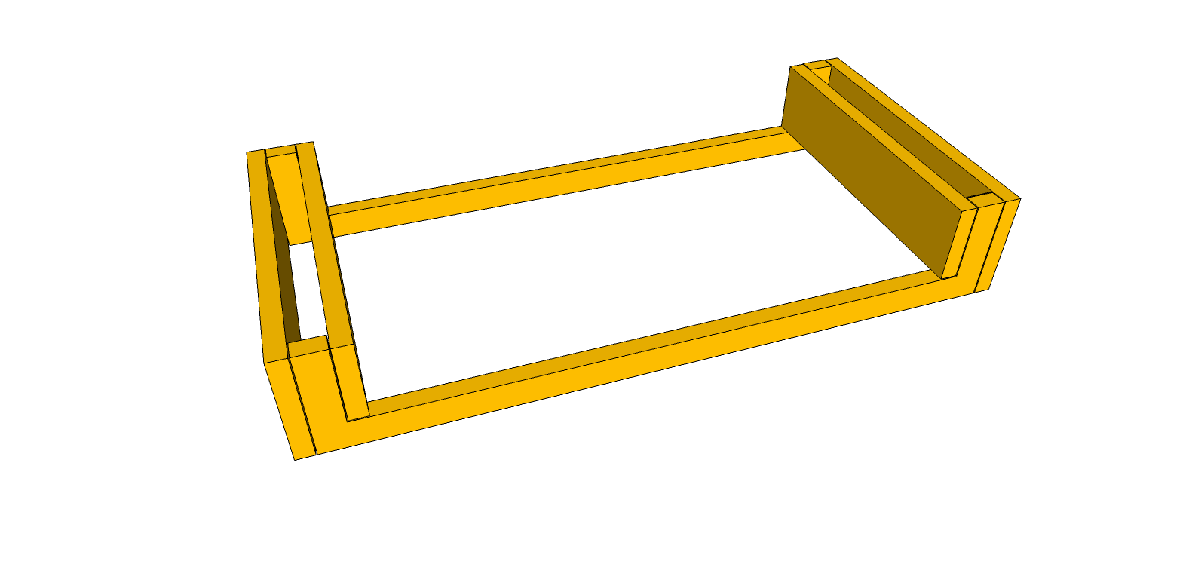

STEP 6: As shown below, bend ¼” mesh rebar to fit inside mold. Approx. dimensions of mesh rebar 1.07 m long x 0.48 m wide x 0.14 m high
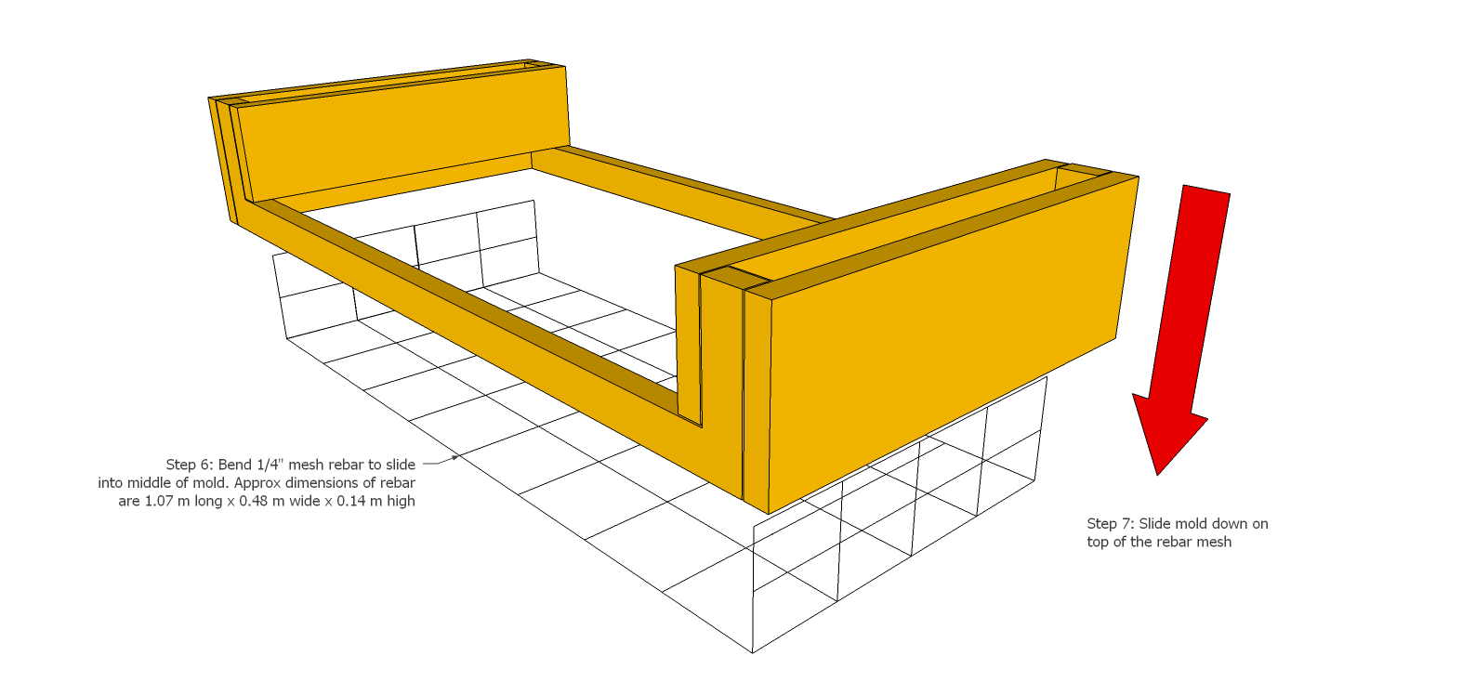

STEP 7: As shown above, slide mold over mesh rebar. Completed Step 7 shown below.
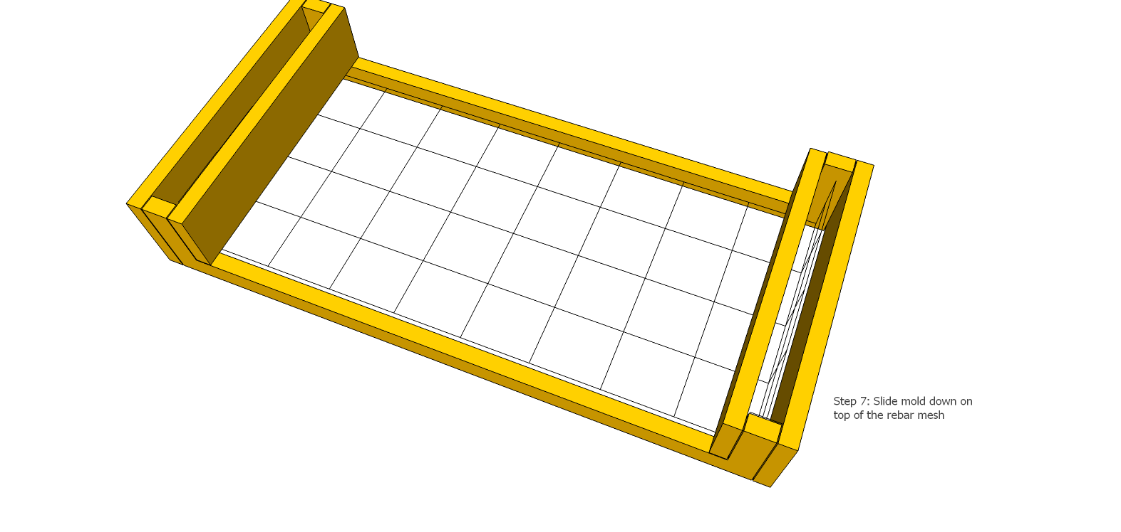

STEP 8: In picture below, see plastic sheet, slightly larger than mold, under mold and rebar on ground. See 2 cm white spacer between plastic sheet and rebar, so cement will surround rebar. Pour mixed concrete on top and into vertical portions of mold as shown
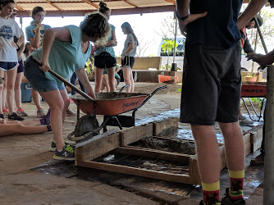
STEP 9: As shown below, smooth concrete with trowel and have fun customizing your lobster house writing your name or fun message on it. Then in a few days after the cement has dried just remove the bolts so you can remove the mold and your lobster house is ready to go.
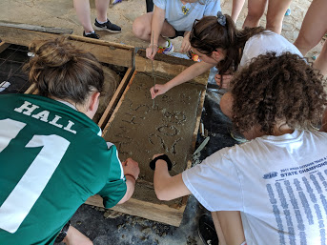
Here is a view 3D view of the mold with the poured concrete:
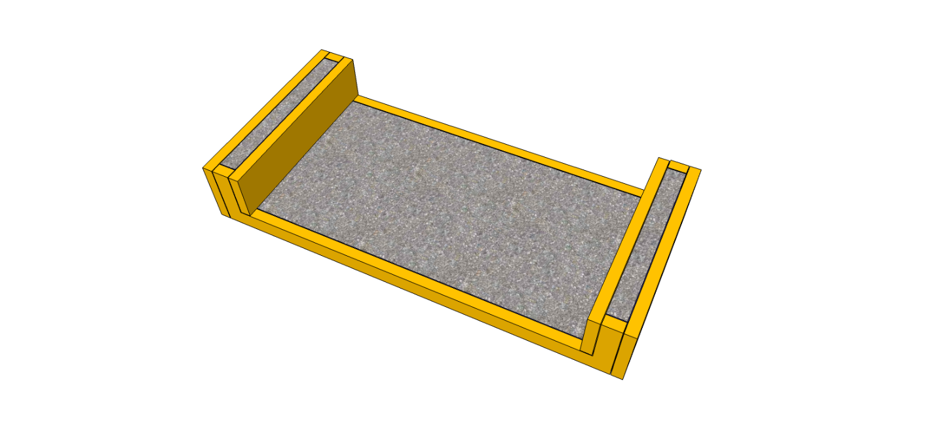

When your Lobster house is ready, sink it in shallow water 18 to 40 feet down on a sandy bottom.
If you don’t have the ability to build and sink a lobster house, but you like the idea and want to help rejuvenate our oceans, TAMTF can to do it for you if you ‘Adopt a Lobster House’.
TAMTF is presently developing a protected artificial reef with an integrated lobster farm off the Pacific coast of Nicaragua that will be owned by the local fisherman. The objective of this project is to teach the local fishermen how to transition from traditional ocean harvesting to sustainable ocean farming. If you are interested, please visit www.tamtf.net for more details.

