Step 1:
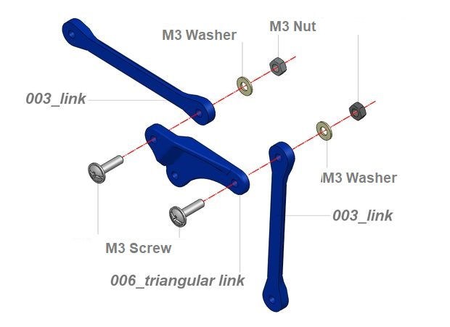
Connect two link arms (003) to the Triangular link (006).
Keep the M3 round heads screws to the inner side like shown on image and nuts to the outer side.
IMPORTANT
I design all the holes of joints quite exact to allow to make them more precise using a drill bit
The nuts are to be tightened till the locking of the joint, then consequently you must loose them until you obtain a smooth movement with the lower clearance between components. This rule is valid and is to be applied also for the following joint that involve use of nuts.

Step 2:
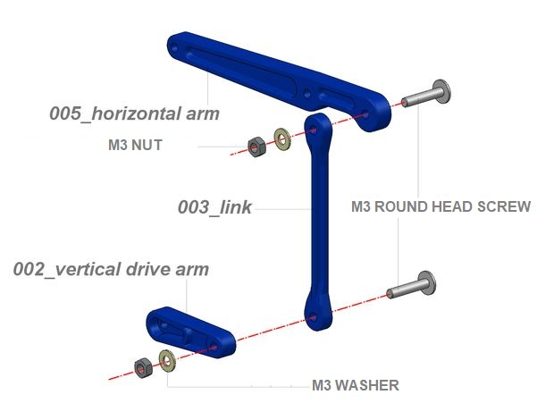
Connect link (003) to the rear joint of the horizontal arm (005).
The lower part of the link (003) is to be connected with the vertical drive arm (002) as shown.
Between the two links interpose three M3 washer, this to better align them with the vertical arm
Keep the M3 round heads screws to the inner side and nuts outside.

Step 3:
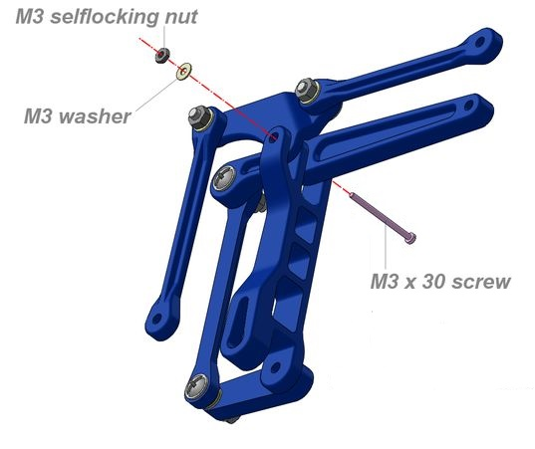

Connect now the two preassembled links to the forward drive arm (004).
Punt in position horizontal arm (005) and triangular link (006) aligned with the upper connection of the forward drive arm (004). Fix all parts with the M3x30 screw, locked by the nut on the other side.
Verify the freedom of movement and If everything is ok, proceed to the next step.

Step 4: Base Assembly
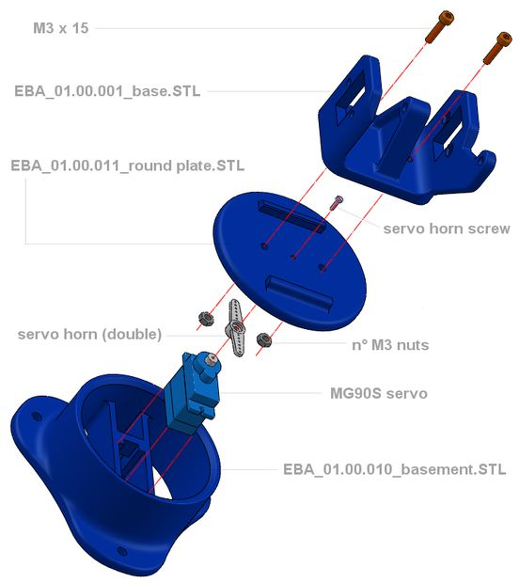

Part list:
· n° 1 EBA_01.00.001_base.stl
· n° 1 EBA_01.00.011_round_plate.stl
· n° 1 EBA_01.00.010_basement.stl
· n° 1 Tower Pro SG90 or MG90S servo with double arm horn
· n° 1 servo horn fixing screw
· n° 2 M3 x 15 screw (VTCEI)
· n° 3 M3 nuts

Step 5:

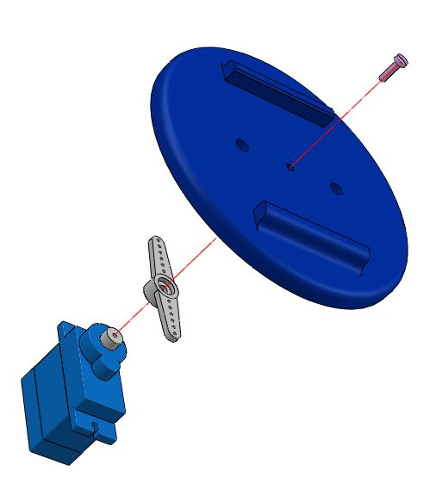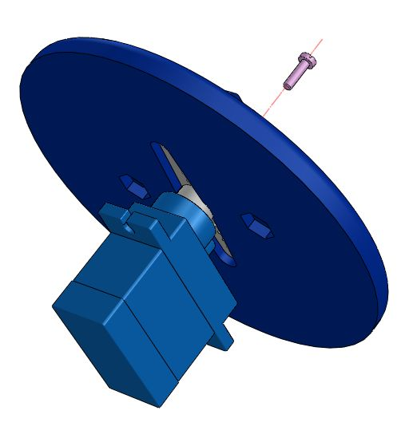
Be sure that the servo is in the neutral position than install the double arm horn on the splined shaft keeping the arms parallel to the servo body
Insert the horn inside the housing below the round plate and fix the servo to the plate using one of the two long screw supplied with the servo (the small one in too short due to the thickness of round plate)

Step 6:

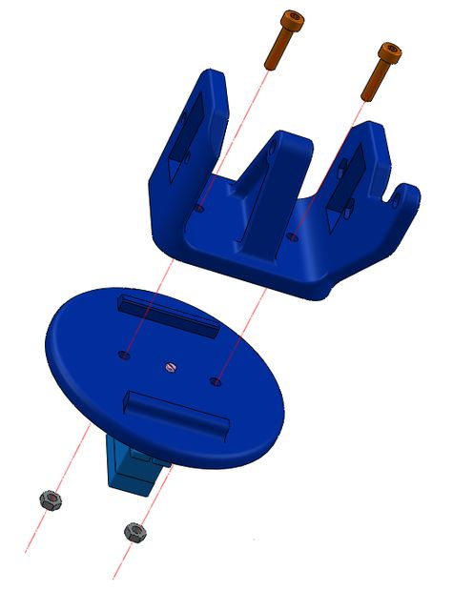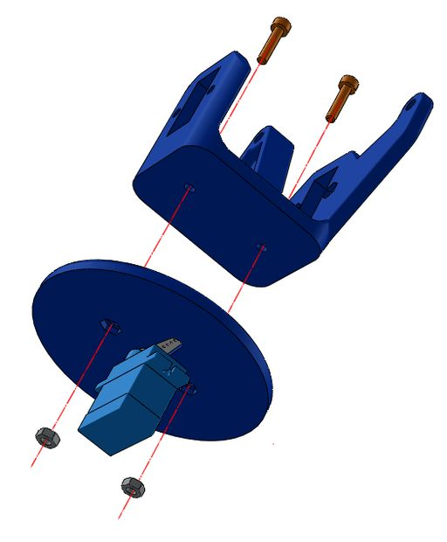
Put in position the base between the two shoulders on the plate and attach together using the two M3 screws and nuts. There two hexagonal housing below, so nuts will be kept in position during tightening

Step 7:

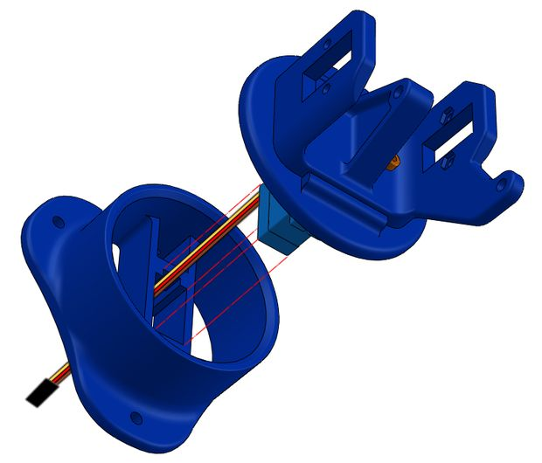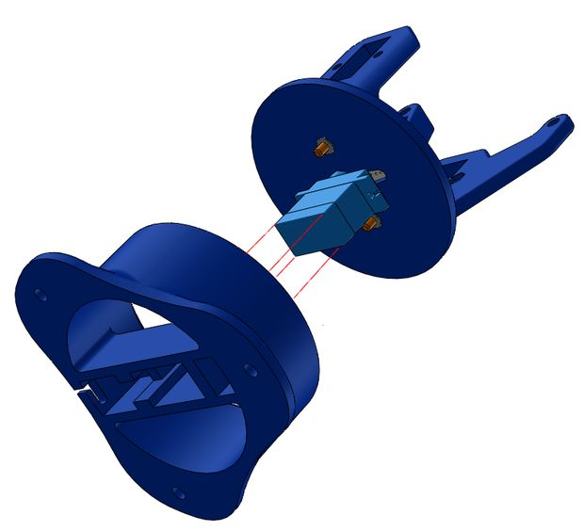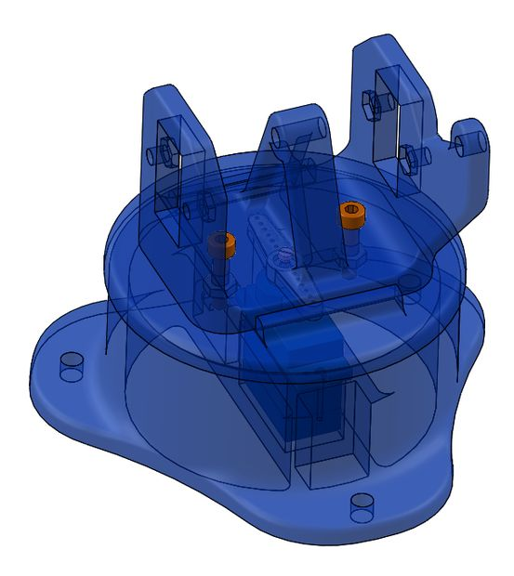
Align the servo and introduce the wiring in the central part of the basement. Gently pull the wire to make it straight while continue to push in it housing the servo
The wire is then kept in position making it pass through a frontal hole

Step 8: Gripper Assembly

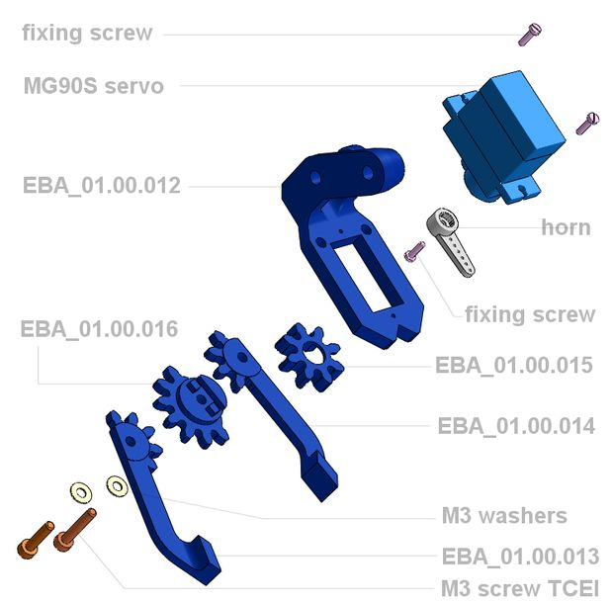
Part list:
· n° 1 TowerPro MG90S or SG90 servo with single arm horn
· n° 1 servo horn fixing screw
· n° 1 EBA_01.00.012_claw support.stl
· n° 1 EBA_01.00.015_drive gear.stl
· n° 1 EBA_01.00.014_left finger.stl
· n° 1 EBA_01.00.016_driven gear.stl
· n° 1 EBA_01.00.013_right finger.stl
· n° 2 M3 x 20 screw (TCEI)
· n° 3 M3 nuts

Step 9:
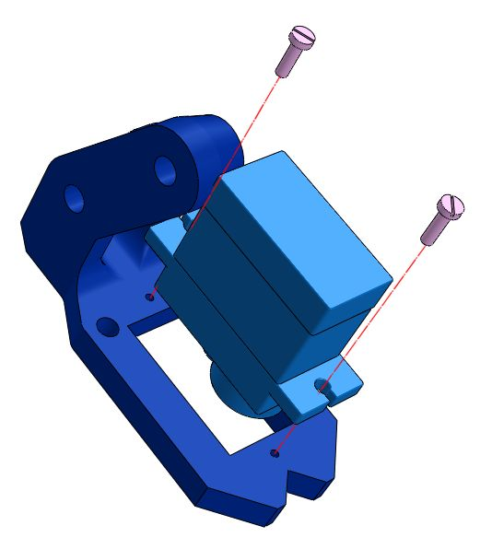
Attach the servo to the claw support using the two fixing screws supplied
with the servo
Keep the output shaft forward.

Step 10:

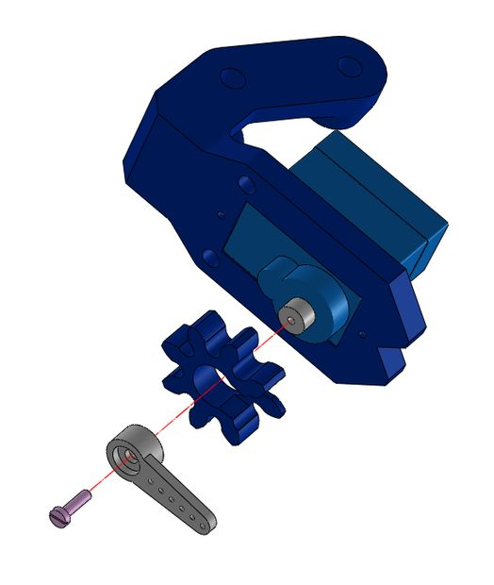

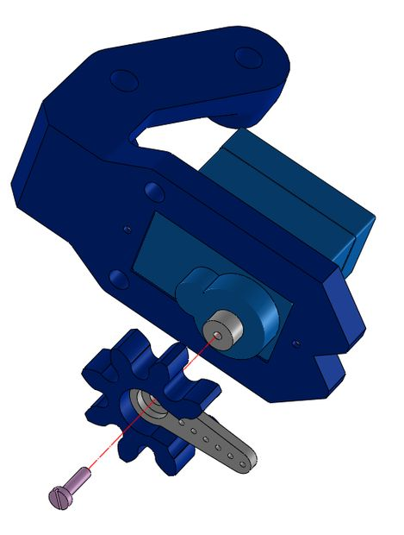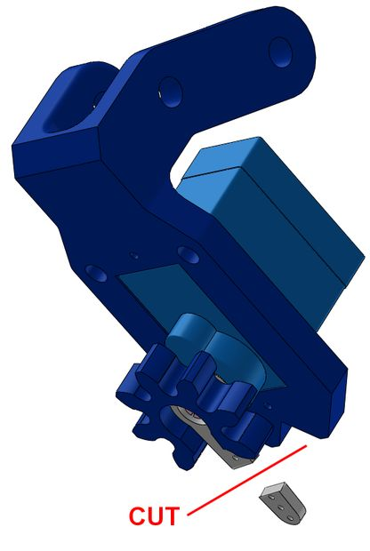
Insert the horn in the driven gear then attach the horn at the servo shaft using the supplied screw
The horn has to be aligned forward with the servo in neutral position. Cut the exceeding part of the horn from gear using a cutter

Step 11:

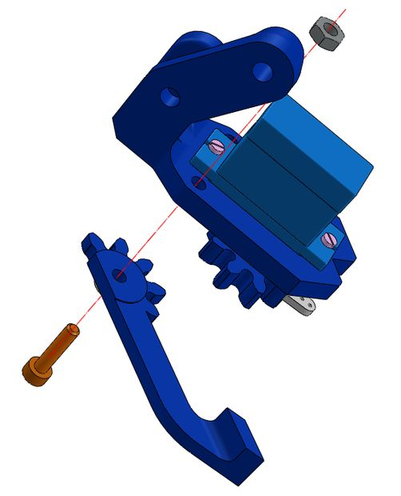
Insert an M3 screw in the central hole connect it to the claw support then tight the nut checking the freedom of movement

Step 12:

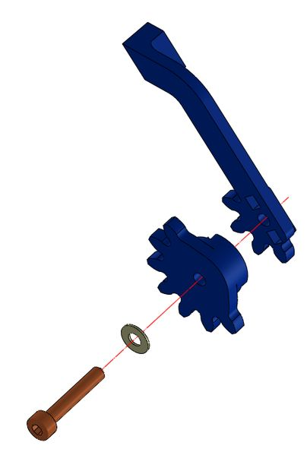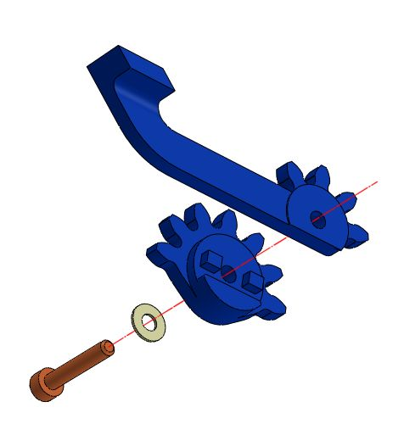

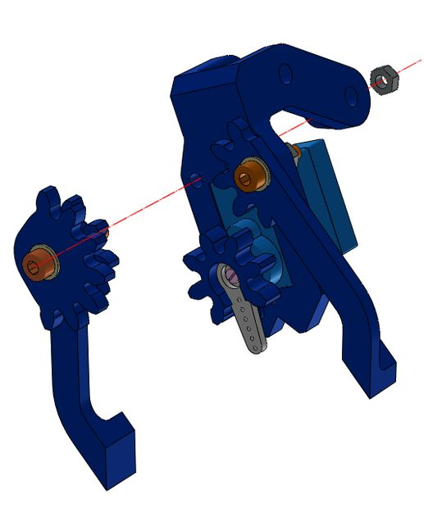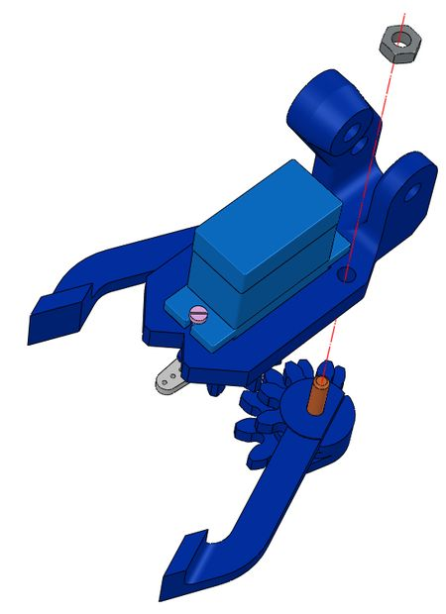
Insert the two pin of the driven gear into the dedicated holes on the left finger the driven gear has also a shoulder that has to be aligned with the lateral side of the finger. If you find difficulties coupling them, reduce interference using a file.
Once coupled insert an M3 screw in the central hole and attach the finger to the claw support
Now the gripper is ready to be installed on the horizontal arm of the EEzybot
Verify freedom of movement of the gripper manually or using a servo tester.

Step 13: Final Assembly.

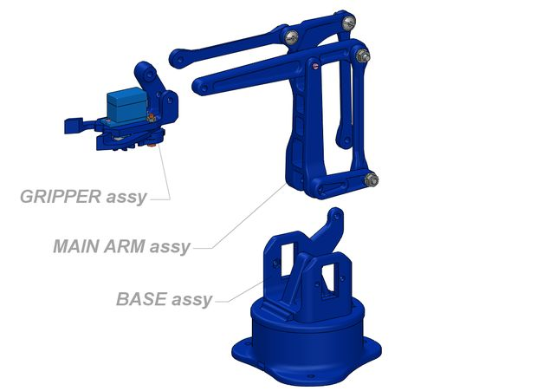
Now we have the three main sub assembly ready to be connected each other.
Next step we will join the base with the main arms

Step 14:

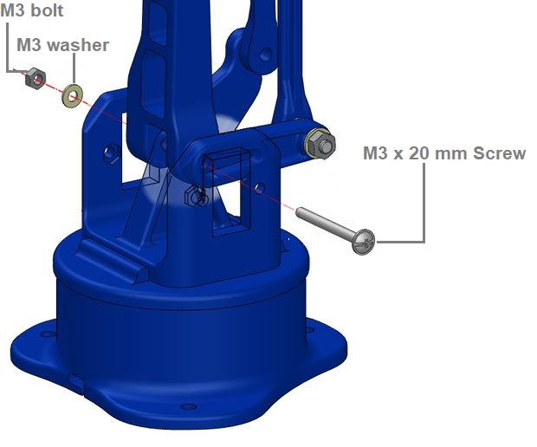

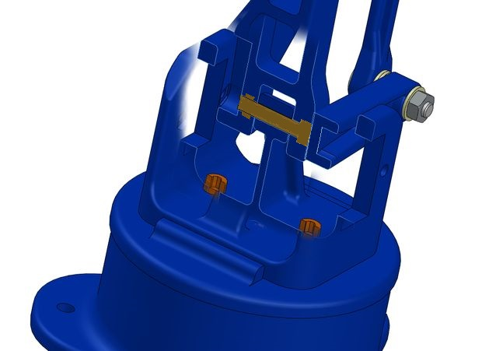
To join the base with the main arms align the axis of the parts and insert from one side the M3 screw 20mm long.
Also the short arm of the servo that drives the vertical movement has to be inserted after the screw as shown on the pictures.
Check the freedom of movement.

Step 15:

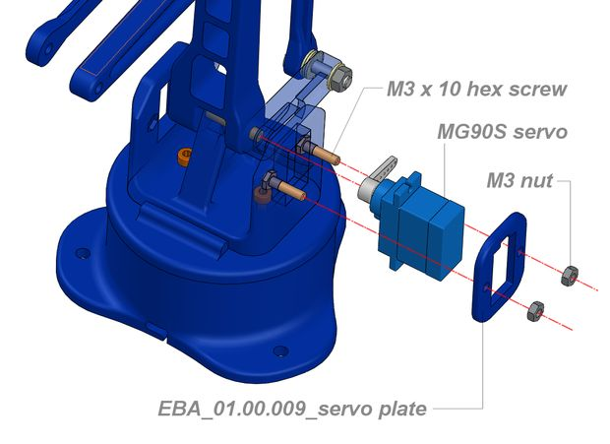

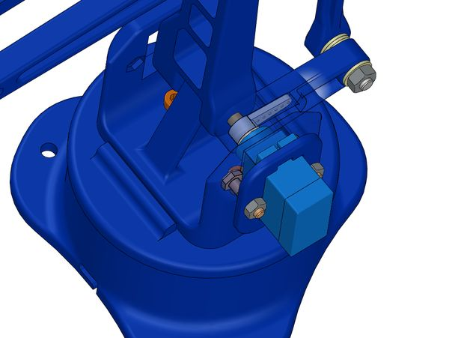
It’s time now to install the servo that drives the vertical movement of the arm. Put in the dedicate receptacles two M3x12 hex screw. The servo has to be in the neutral position with the horn at 90 degrees on the right side with the press plate (009) installed (Make the wiring pass through the dedicated enlargement).
Introduce the servo angled in the square seat on the base plate and slide the horn in the shaped housing of the arm that drives the vertical movement. Fix the press plate against the servo using two M3 nuts

Step 16: Fwd/bckw Drive Servo

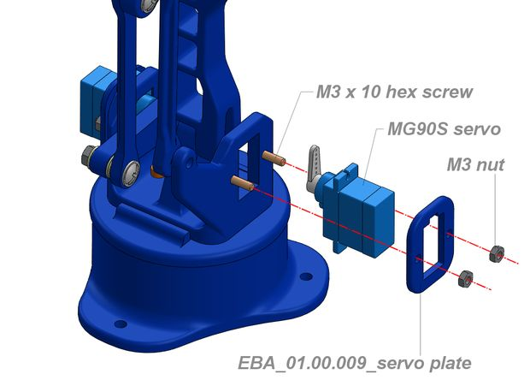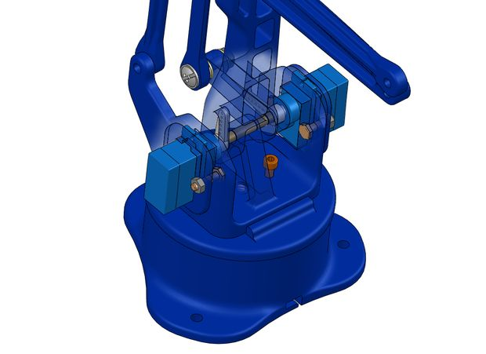
Sequence for the forward & backward driving servo is similar to the previous. In this case the servo horn has to be installed with the servo in neutral condition aligned vertically.

Step 17: Last Link

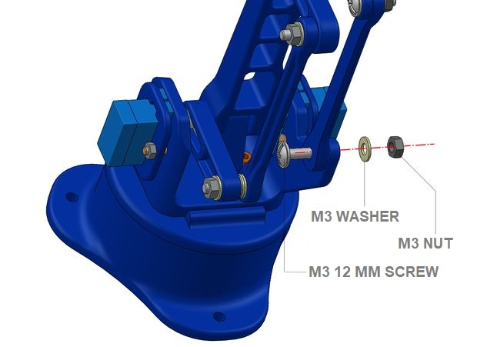
Attach the latest link to the fixed arm on the rear side of the base using a M3x12 a washer and a nut

Step 18: Attaching the Gripper

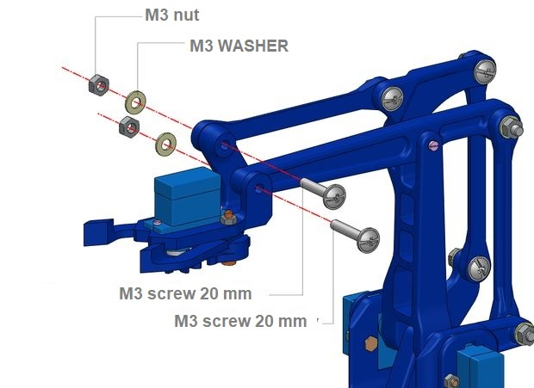

The last assembly step is to join the gripper to the horizontal arm as shown on the picture.

